Sedo Oh

1.8

A) Smoking habits of UK residents

B) 1691

C) Sex – categorical

Age – numerical, discrete,

Marital – categorical

Gross income – numerical, continuous

Smoke – categorical

amtWeekends – numerical, continuous

amtWeekdays – numerical, continuous

1.10

Population of Interest – children age between 5 and 15

Sample – 160 children age between 5 and 15

1.28

A) No. Smokers in general may have other types of activity associated with smoking that may contribute to dementia

B) No, not justified. There are other factors such as unstable family relationship that leads to sleep disorder. And it may be that such family situation is the one that causes the sleep disorder as well as disruptive behavior

1.36

A) experimental study

b) Treatment – people who exercise

control – people who do not exercise

c) yes, age groups

d) no blinding

e) yes, can be used to establish relationship with large sample to a certain extent. And it can be generalized to the population to a certain extent if each subgroup shows that exercise improves mental health

f) Reservation includes

1) may be too expensive to get random sample that’s enough in size

2) the fact that the subjects are taking mental exam itself can have impact on mental health.

1.48

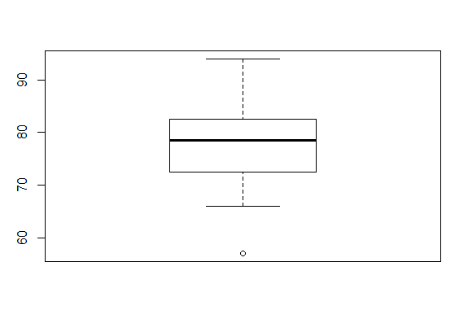

1.50

a-2

b-3

c-1

1.56

A) Right skewed since there is greater gap in housing price to the right of median price.

Median is the better measure since extreme housing values can have large impact on average

IQR will likely to show better range and spread of the housing price since there’s a good range of the prices of expensive end of the houses

B) symmetric, since there is even range of the price around the mean.

Median is still a good measure to fend off extreme housing values

IQR will still manage to be a good display of the spread of prices since average housing price is impacted by the more expensive housing prices out there

C) right skewed since most kids will not drink

Median works better since it will most likely be zero which is fairly accurate considering most will not drink

IQR still works here to see for those that drink, how much they are drinking.